**Nurtai Maksat** CSSE-1605

Report – Random Forest

Random Forest, using this model is no different from "DT". The difference is that in this model you can use additional and quite influential parameters. However, we must not forget that they are completely different prediction algorithms. On tasks I used such parameters as: criterion='entropy', max_depth=2, min_samples_leaf=2, random_state=0, n_estimators=100, min_samples_split=3. The most interesting thing is that these parameters (my parameters) are not always the best. That is, in the classroom, I discovered that random_state also affects the result. The results of my work were as follows:

1. Task_1: Social Network Ads dataset

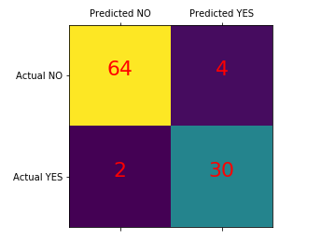

2. Taks_2: Heart dataset

